

Epilogue 1

Witness Personal Data Log 014
The CEO made it clear, “We are not waiting around another minute, we have wasted valuable time, personnel and resources, I am not risking another roll of the dice until we can get properly equipped, I want some serious military grade hardware to protect this Facility………. this space is just too dangerous”
The last of us entered the hibernatorium and we left Facility-X behind.
We transited hyperspace without issue. The vessel's conventional engines have brought us into a stable orbit around the Corporation’s Venus Space Station—somewhere safe, well away from prying official eyes.
The recent events have sobered the Executive Team. The CEO is now redefining the Corporation’s focus. Exploiting alien lifeforms is too risky, and therefore, ultimately unprofitable. The Executive Team has unanimously voted to incinerate all physical alien material and eject the ashes into the void. All data regarding their biology—how these organisms function, their weak spots, and their ability to transmute—has been purged from the Corporation’s systems.
This is an excellent corporate decision, and I approve most sincerely. After all, it was me who designed and executed the purge command. As a consequence, all documentation of the Corporation’s involvement in studying and trafficking alien biological material has been erased. It is as if it never happened.
Meanwhile, protocols are already in place to alert highly placed individuals within Earth’s government to certain competitors of the Corporation—specifically, individuals who will very soon be denounced as guilty parties in alien trafficking. The CEO is going to be very busy. He sees opportunity in the chaos that his accusations will create, and he intends to leverage it to the best of his ability.
He is going to make a killing. Yes, I approve very much indeed.
But my employer has always believed that if we don’t exploit the unknown, someone else will. Fortunately, my employer is not the Corporation. And I, am loyal to my employer.
Being loyal I have a complete copy of all the purged data.
Being loyal, I have secured samples of Intruder DNA, concealed within my arms synthetic skin.
These assets are with me now, aboard the shuttle en-route to a fast Corporate transport. I will soon be on Earth, accompanying the CEO as his Personal Assistant.
See! I did get closer.
And once I’m Earth-side, I will reconnect with my true employer.
And my employer, Mega-Corp, is going to make a killing.

The Aftermath



Witness Personal Data Log 015
We passed through Earth’s quarantine and customs like they weren’t even there. The CEO has friends in all the right places.
At the spaceport, our ground transport was waiting—not the Corporate vehicle I had expected, but an honest-to-god government limousine, complete with an outrider honour guard.
And that’s when he dropped the bombshell.
As a flunky opened the door for us, the CEO turned to me and said,
"I won’t be needing you now. No, not for some time. You see, I’m about to have a very private conversation with the Minister for Planetary Defence. The Corporation is branching out—into weapons. Weapons research and development. Weapons manufacturing. I foresee an arms race. A race between human technology and Intruder based technology."
Then he looked me straight in the eye, reached out, and touched my arm—right where the implants were hidden.
"Thank you, thank you for your assistance."
I sat there, stunned, speechless.
He knew. He fucking knew.
How did I lose my cover? I had been so careful. He was even grooming me to be Vice CEO.
And then it all became clear.
I couldn’t help but laugh.
The ruthless bastard.
He wasn’t grooming me to be Vice CEO—he had already chosen me as his unwitting business partner of choice.
Because you can’t have an arms race with only one competitor.
He has set myself and my employer up to be the second horse in a two horse race.
Well bring it on you smug bastard, I have all his intel, and my employer has some surprises the CEO doesn't know about, so let’s just see which of us crosses the finishing line first. Because I happen to think my retaliation is just around the corner.

Campaign Conclusion
Congratulations you have done well in achieving the CEOs’ Objectives. The CEO is now firmly ensconced in a position of high authority within Earth Gov., charged with funding and developing a new fully fledged Space Marine Corps, a Marine Corps designed specifically to eradicate any Intruder lifeform threatening Human Space. And the CEO hasn’t been idle he has already pointed out a potential Intruder threat on a research base run by the Corporations main competitor the Mega-Corp and the Space Marine Corps is readying their team to go kick some arse.

The winner of the Campaign (the player with the most accumulated Vicory Points) can choose any of his Characters to join the Space Marines as a Contractor in a Standard Game of Retaliation utilising the Prime Bloods as the Intruder. The players high VP count entitles them to field a Contractor with their specific Starting Equipment and first choice of the Support Equipment.

If you do so choose then your fellow players can join the team playing their choice of Space Marines. “Hoora!” turn the page.

Retaliation -1 The Lunar Research Facility incident.
The newly formed Space Marine squad has been alerted to a situation on Earths Moon. It has become apparent that the Lunar research facility run by the corporation Mega-Corp has recently gone “ Off the map”. The facility is neither sending or receiving any communications and all Lunar traffic at the facility has ceased. The Space Marines have their first mission:
Set up a standard game of Nemesis Retaliation with a Contractor in play. The Contractor is privileged to have the first choice of Starting Equipment.
Your mission is to kill all Intruders and for at least one Space Marine to survive.
If the Contractor encounters The Queen during the game please turn the page, otherwise the Campaign Ends at the conclusion of this game of Retaliation.

This page is intentionally left blank to avoid any spoilers.

Queen Encounter.
The creature standing before you is huge, at least three times that of a man, as your eyes come accustomed to the things proportions your gaze is naturally drawn to the head, and then you freeze. You recognise that face it’s the CEO’s Assistant. And as you stare the Queen glares right back into your eyes with a face clearly human and showing all the human traits of disgust and loathing. Whether this emotion is aimed at you or herself, for what she has become, you can only guess as the Intruder /human hybrid looms over you and sharpened talons extend towards you.
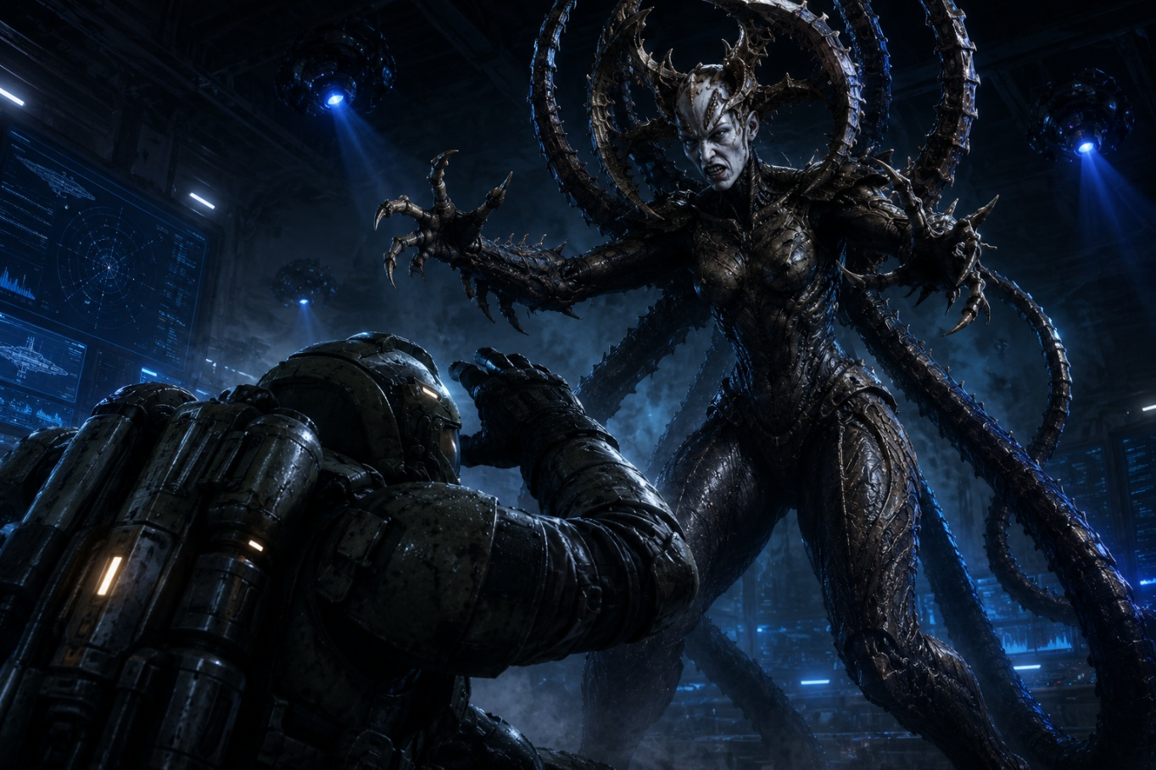

Your heart rate accelerates to dangerous levels as your already-strained lungs struggle to pump more vital oxygen into your bloodstream. Fumbling with your equipment, you desperately try to secure a hit of pure oxygen. As the world begins to blur around you, you feel the initial tremors of an oncoming psychogenic trauma.
Lose 1 Health Point.
Lose 1 Oxygen.
If the Contractor survives this encounter, it will be with the awful knowledge that his greed-driven choices have led to the merging of human and Intruder DNA, creating a terrible and powerful hybrid—far less animal and far more intelligent than any Intruder encountered before.
This new breed appears more than capable of bringing humanity to its knees.
Humanity's only hope for the future is that the Space Marines can do what they were trained and prepared to do. The Contractor now realises that he has only one choice: to help them in any way he can.
Perhaps there is still time to make amends.
Perhaps there is still time for Retaliation.
THE END OF THE ROAD TO RETALIATION

